Support Vector Machine Algorithm

Support Vector Machine or SVM is one of the most popular Supervised Learning algorithms, which is used for Classification as well as Regression problems. However, primarily, it is used for Classification problems in Machine Learning.

The goal of the SVM algorithm is to create the best line or decision boundary that can segregate n-dimensional space into classes so that we can easily put the new data point in the correct category in the future. This best decision boundary is called a hyperplane.

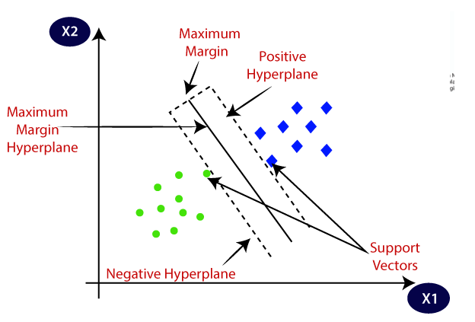

Example: We will first train our model with lots of images of cats and dogs so that it can learn about different features of cats and dogs, and then we test it with this strange creature. So as support vector creates a decision boundary between these two data (cat and dog) and choose extreme cases (support vectors), it will see the extreme case of cat and dog. On the basis of the support vectors, it will classify it as a cat.

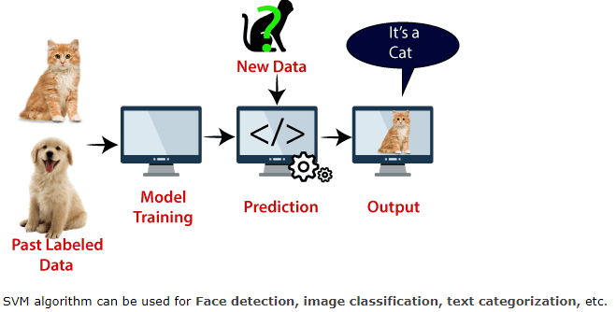

## Basic Linear Algebra

## Vectors :

Vectors are mathematical quantity which has both magnitude and direction. A point in the 2D plane can be represented as a vector between origin and the point.

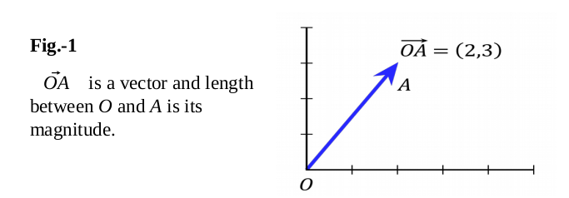

## Length of Vectors

Length of vectors are also called as norms. It tells how far vectors are from the origin.

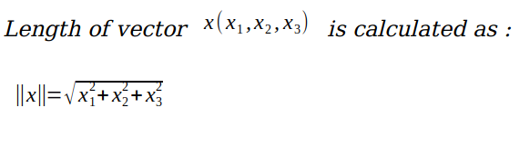

**Hyperplane:**

Hyperplanes can be considered **decision boundaries**that classify data points into their respective classes in a multi-dimensional space. Data points falling on either side of the hyperplane can be attributed to different classes.

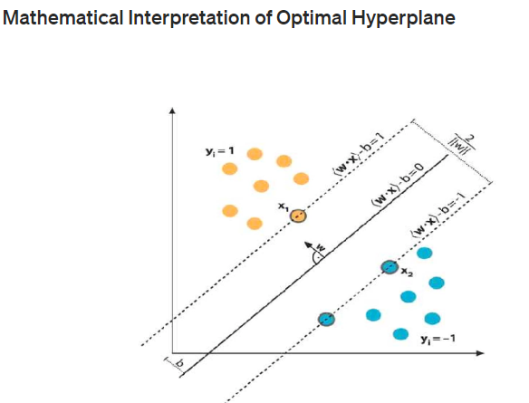

### Image for post

### Classifier

Once we have the hyperplane, we can then use the hyperplane to make predictions. We define the hypothesis function h as:

**h(xi)={+1−1if w⋅x+b≥0if w⋅x+b<0h(xi)={+1if w⋅x+b≥0−1if w⋅x+b<0**

The point above or on the hyperplane will be classified as class +1, and the point below the hyperplane will be classified as class -1.

So basically, the goal of the SVM learning algorithm is to find a hyperplane which could separate the data accurately. There might be many such hyperplanes. And we need to find the best one, which is often referred as the optimal hyperplane.

## ****Dot Product****

Dot product between two vectors is a scalar quantity . It tells how to vectors are related.

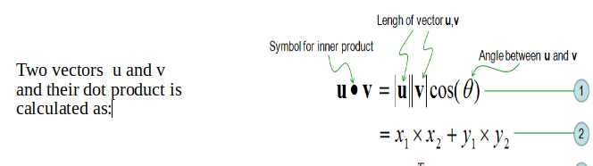

SVM algorithm can perform really well with both linearly separable and non-linearly separable datasets.

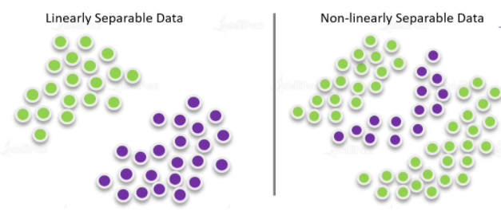

**Support Vector Machine Algorithm Example**

Support vector machine or SVM algorithm is based on the concept of ‘decision planes’, where hyperplanes are used to classify a set of given objects.  
we have two sets of data. These datasets can be separated easily with the help of a line, called a **decision boundary**.

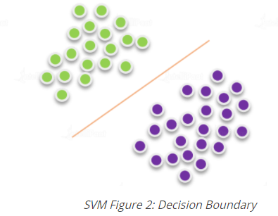

But there can be several decision boundaries that can divide the data points without any errors. For example, in Figure 3, all decision boundaries classify the datasets correctly. But how do we pick the best decision boundary?

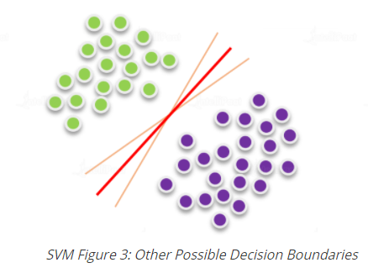

Well, here’s the the best decision boundary is the one which has maximum distance from the nearest points of these two classes, as shown in Figure 4.

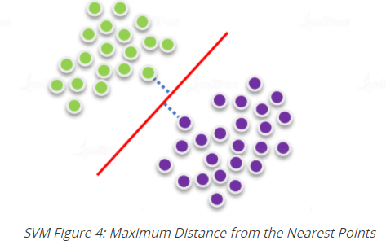

Also remember that the nearest points from the optimal decision boundary that maximize the distance are called **support vectors**.

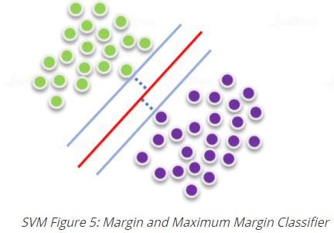

The region that the closest points define around the decision boundary is known as the **margin**.  
That is why the decision boundary of a support vector machine model is known as the **maximum margin classifier** or the **maximum margin hyperplane**.

In other words, here’s how a support vector machine algorithm model works:

* First, it finds lines or boundaries that correctly classify the training dataset.
* Then, from those lines or boundaries, it picks the one that has the maximum distance from the closest data points.

The above support vector machine example, the dataset was linearly separable. Now, the question, how do we classify non-linearly separable datasets.

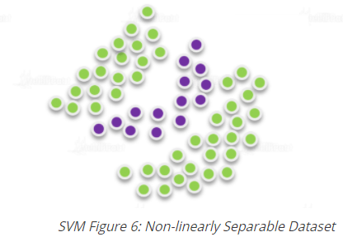

Clearly, straight lines can’t be used to classify the above dataset. That is where Kernel SVM comes into the picture.

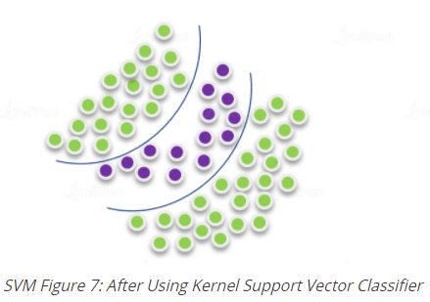

The Kernel SVM projects the non-linearly separable datasets of lower dimensions to linearly separable data of higher dimensions. Kernel SVM performs the same in such a way that datasets belonging to different classes are allocated to different dimensions.

**Advantages of Support Vector Machine Algorithm**

* Accuracy
* Works very well with limited datasets
* Kernel SVM contains a non-linear transformation function to convert the complicated non-linearly separable data into linearly separable data.

**Disadvantages of Support Vector Machine Algorithm**

* Does not work well with larger datasets
* Sometimes, training time with SVMs can be high

## **Building a Support Vector Machine (SVM) Classification Model in Machine**

Machine learning to predict cases of breast cancer using patient treatment history and health data

Example: Placement Dataset

**Step1:** Import libraries and load data

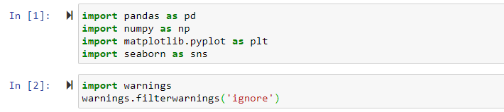

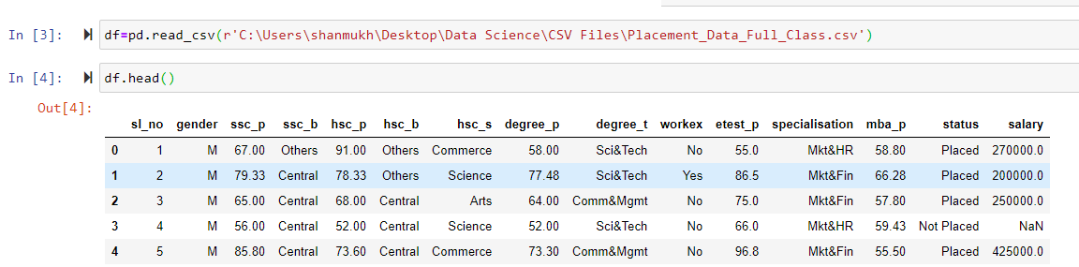

Step 2: Checking null values

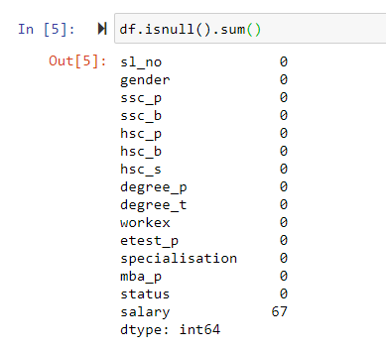

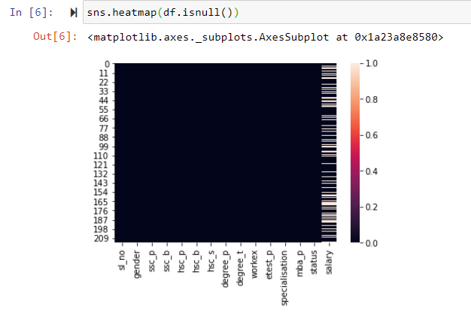

Replacing Null values with Mean

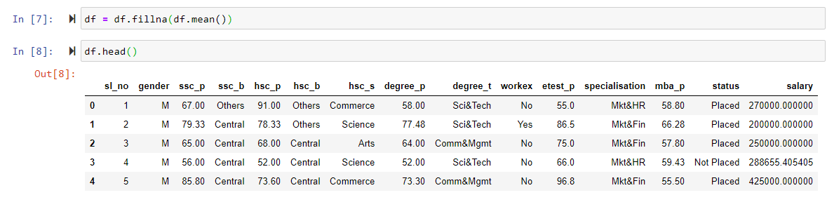

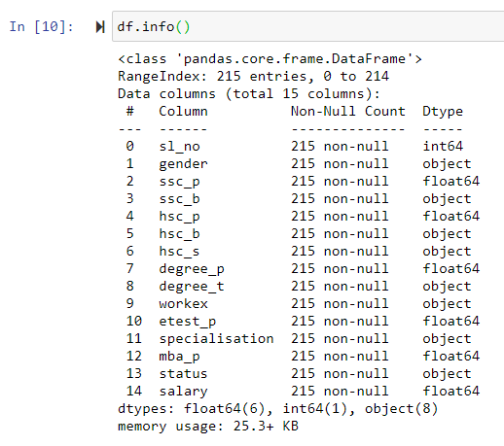

Step 3: Encoding data

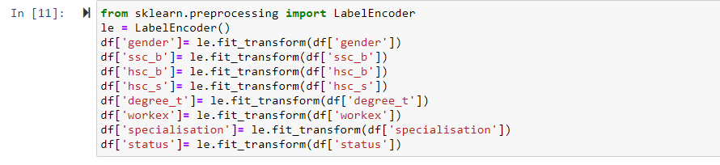

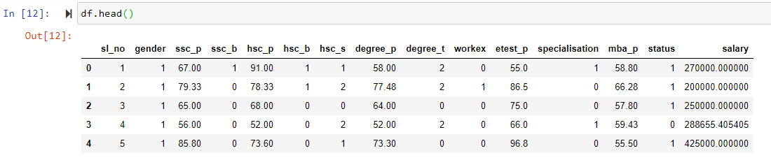

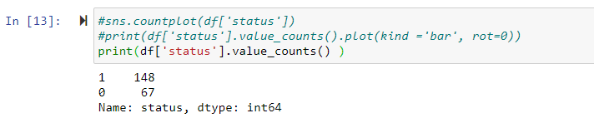

Step 4: Balanced and Imbalanced data

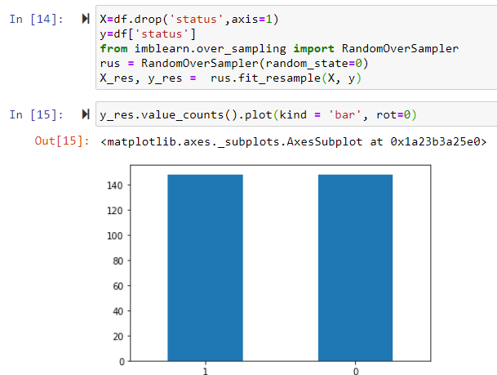

Step 5: Checking the Correlation

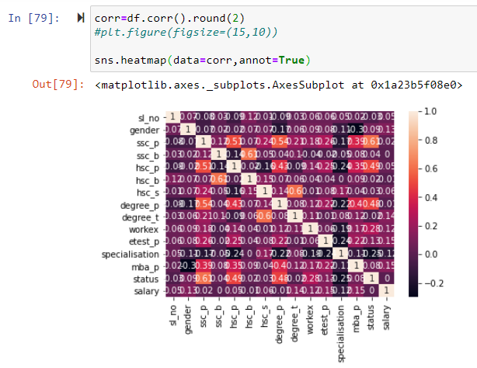

Step 6: Train & Test data

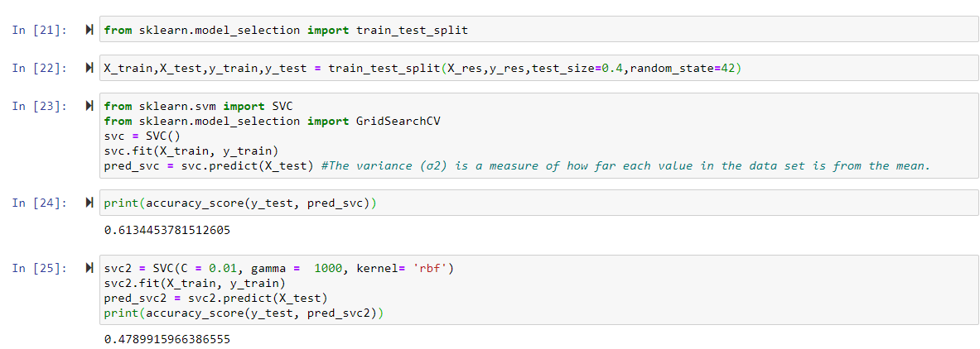

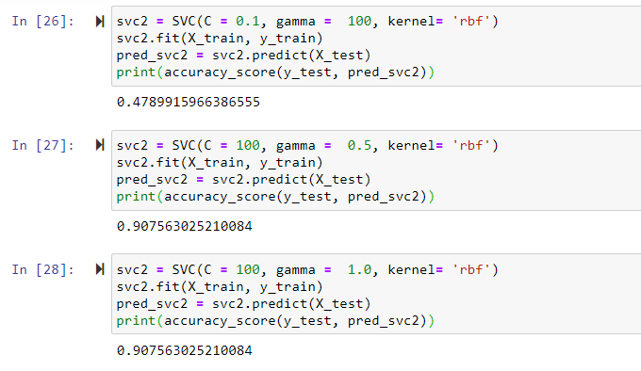

Hyper tuning Parameters:

